SSURGO Digital Soil Survey Installation Instructions:

- Print this page to have available during application installation/removal.
- Using Windows Explorer, navigate to CD root directory and double-click the setup executable file.
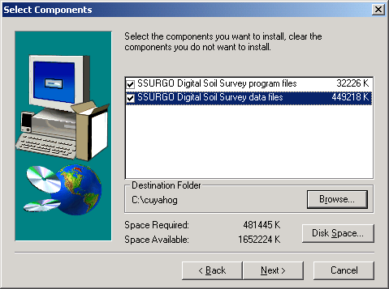
- Be certain to read each setup dialog carefully.
- Important. Select the checkbox to add SSURGO Digital Soil Survey data files.

Including data files is required.

- Next, choose the default installation directory by clicking on Next for “Select Program Folder” or navigate to an alternative directory location.
- Write down installation directory (you will need this later). __________________
- Confirm directories in “Information” (“Setup Summary”) and click Next to begin transferring application files.

IMPORTANT. YOU ARE NOT YET DONE.

- After the application has finished installing, use Windows Explorer to locate the installation directory (See Step 6). Note: If folders do not appear, press the F5 key to refresh system files.
- Navigate through the installation directory’s /data/ folder and double-click the Class_Themes executable file.

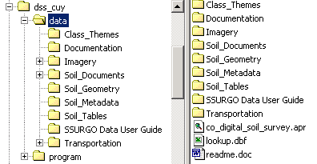
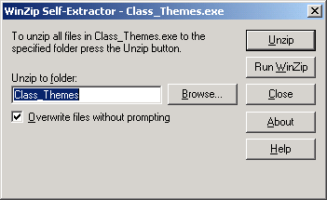
Double-click to unzip.
- Choose the Unzip button and allow data to inflate in default location. This step may take several minutes to complete.
- Once completed, you may access the application through your computer’s Start > Programs menu. Additional application instructions are provided from the “SSURGO Digital Soil Survey” drop-down menu (View >Readme File and Reference Guide).
SSURGO Digital Soil Survey. Application Removal Instructions:
Due to limited availability of hard drive storage, users may wish to uninstall SSURGO Digital Soil Survey applications while not in use. See instructions below.

- Access the Add/Remove Programs application through your computer’s Start > Settings > Control Panel menu.
- Scroll down until you reach the “County” SSURGO application you wish to remove. Select the application.
- Choose the Change/Remove Button
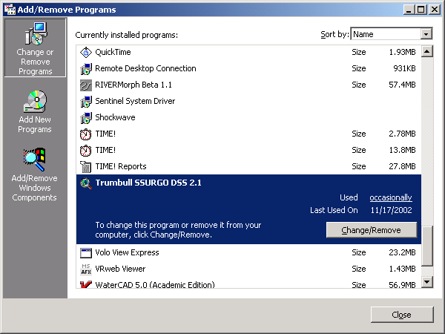
- Continue with defaults and do not remove any shared files. These are primarily ESRI fonts that may be in use by other SSURGO DSS applications running on your computer.

IMPORTANT. YOU ARE NOT YET DONE.

- After the application has finished uninstalling, use Windows Explorer to locate the installation directory (See Step 6 from installation instructions).
- Delete the dss_xxx county folder and all subfolders to properly remove the contents of the Class_Themes that you previously unzipped (See Step 10 from installation instructions).

